**Unit 1: Operating System Architecture**

* **1.2. Operating System Design Goals and Principles**
* Citing examples from Linux explain how operating system design goals and principles influence kernel design and implementation strategies. **[2026 Spring]**
Design goals are the objectives an operating system aims to achieve, such as performance, flexibility, portability, maintainability, reliability, and security.
Design principles are the rules, techniques, or guidelines used to achieve those goals, such as modularity, abstraction, separation of mechanism and policy, protection, and efficient resource management.
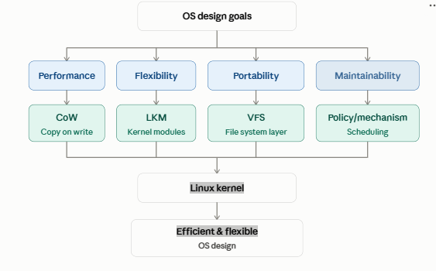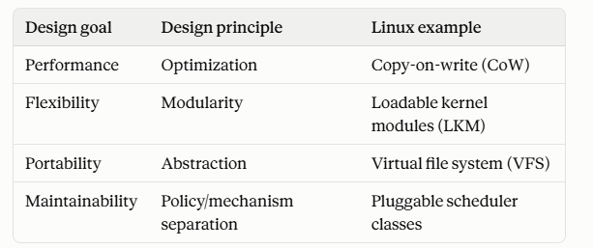
Principle | Area | Strategy | Example
Separation | CPU | Scheduling | CFS + Red-Black Tree
Modularity | Device | Dynamic modules | LKM + insmod/modprobe
Simplicity | Process/Thread | Unified task model | task_struct + clone()
Performance | Memory | Avoid duplication | Copy-on-Write (CoW)
OS Design Goal / PrincipleTarget Architectural AreaLinux Kernel Implementation StrategyConcrete Code/System ExampleSeparation of Policy & MechanismCPU Resource Allocation
Decoupled scheduling policies managed via a balanced binary tree.
Completely Fair Scheduler (CFS) using a red-black tree.
Modularity & AdaptabilityExtensibility & Device Support
Dynamic loading of optional driver code into a unified monolithic address space.
Loadable Kernel Modules (LKMs) (e.g., insmod, modprobe).
Simplicity ("Be Wary of Complexity")Execution Unit Management
Unifying processes and threads under a single internal kernel model.
Mapping all units to a distinguishable task via task_struct and clone().
Performance OptimizationMemory Allocation
Deferring expensive physical memory duplication during process duplication.
Copy-on-Write (CoW) optimization on shared memory pages.

